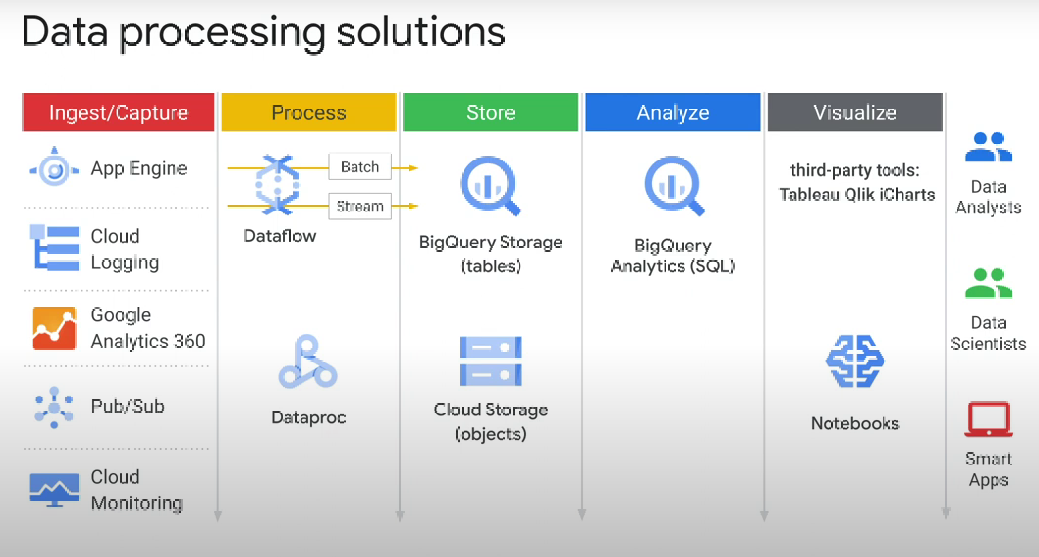

if you need more capabilities than a query engine (BigQuery) consider cloud dataproc or

cloud dataflow:

